|  |
| --- |
| 1. **Power on Rack instruments** |
| ☐ Confirm 2 USB drives are plugged in |
| ☐ Confirm aircraft rack power is on |
| ☐ Rack power *(push in breaker on back strip)* |
| ☐ IF Box |
| ☐ TX Switch on IF Box is down |
| ☐ Confirm *(with RAF tech)* time server is up |
| ☐ Archiver computer *(upper left button)* |

|  |
| --- |
| 2. **Pod Power** |
| ☐ Request power to pod in the order below: Right breaker -> Left breakers |
| ☐ Power on Transmitter CMU |
| ☐ Confirm ‘Power Valid’ is green on CMU |

|  |
| --- |
| 3. **Start up Archiver computer** |
| ☐ Unplug & plug in the USB for keyboard |
| ☐ Log in *(user: HCR user/passwd:sun-dog)* |
| ☐ Open a Terminal |
| ☐**‘start_all’** command at prompt |
| ☐ Confirm 2 USB drive status |

|  |
| --- |
| 4. **Xchat** |
| ☐ Click on Xchat icon |
| ☐ Change username *(type: /nick <name>-gv)* |
| ☐ Join additional channel *(type: /join #name)* |

|  |
| --- |
| 5. **Start up RDS computer** |
| ☐ Open another Terminal in Archiver |
| ☐ SSH into RDS *(simply type ‘rds’)* |
| ☐**‘start_all’** command at prompt |

|  |
| --- |
| 6. **HCR GUI** |
| ☐ Double click ‘Start HCR GUI’ icon |
| ☐ Double click ‘Start HawkEye 10Hz’ icon |

|  |
| --- |
| 7. **C-migits Initialization** |
| ☐ Check Cmigits is in ‘Fine Alignment’* |
| ☐ LED light turns green when done |
| *(* ‘Air navigation’ is displayed when initialization is completed.)* |

|  |
| --- |
| 8. **HCRDRX** |
| ☐ Double click ‘Start hcrdrx.ops’ icon |
| ☐ Double click ‘View hcrdrx.log’ icon |

|  |
| --- |
| 9. **Motion Control** |
| ☐ Confirm TX Switch is in down position |
| ☐ Home the Drives using HCR GUI |
| ☐ Confirm Home Drives dialog – click ‘ok’ |

|  |
| --- |
| 10. **Transmitter** |
| ☐ Click ‘Filament’ on HCR GUI *(~2.5 min)* |
| ☐ Confirm the Ops Mode – Bench-Test |

|  |
| --- |
| 11. **PI HawkEye Display** |
| ☐ Open a terminal |
| ☐**‘ssh –XY hcr@hcr-router’***(sun-dog)* |
| ☐**‘start_HawkEye.10hz &’** |

|  |
| --- |
| 12. **Noise Source CAL** |
| ☐ Click GUI ‘Request High Voltage’ button |
| ☐ Change Ops Mode – Noise Source CAL* |
| ☐ Calibration for 5 minutes |
| ☐ Change Ops Mode – Bench-Test |
| *(*NSCAL only works with High Voltage On)* |

|  |
| --- |
| 13. **Configure Ops Mode & Transmission** |
| ☐ Perform this section ONLY when taxiing. |
| ☐ Confirm Cmigits status light is **green** |
| ☐ Confirm HCR is pointing **up** |
| ☐ Click GUI ‘Request High Voltage’ button |
| ☐ Set Request Ops mode to ‘Tx-V, Rx-HV’ |
| ☐ Flip **up** TX Switch to transmit |
| *(CMU may require power cycle when RS232 comm. is lost)* |

|  |
| --- |
| 14. **Archiver Status Monitor** |
| ☐ Double click on ‘View archive.log’ icon |
| ☐ Verify the data writing status on GUI |
| ☐ Check the USB3 drives are keeping up |

**HCR Breaker Location**

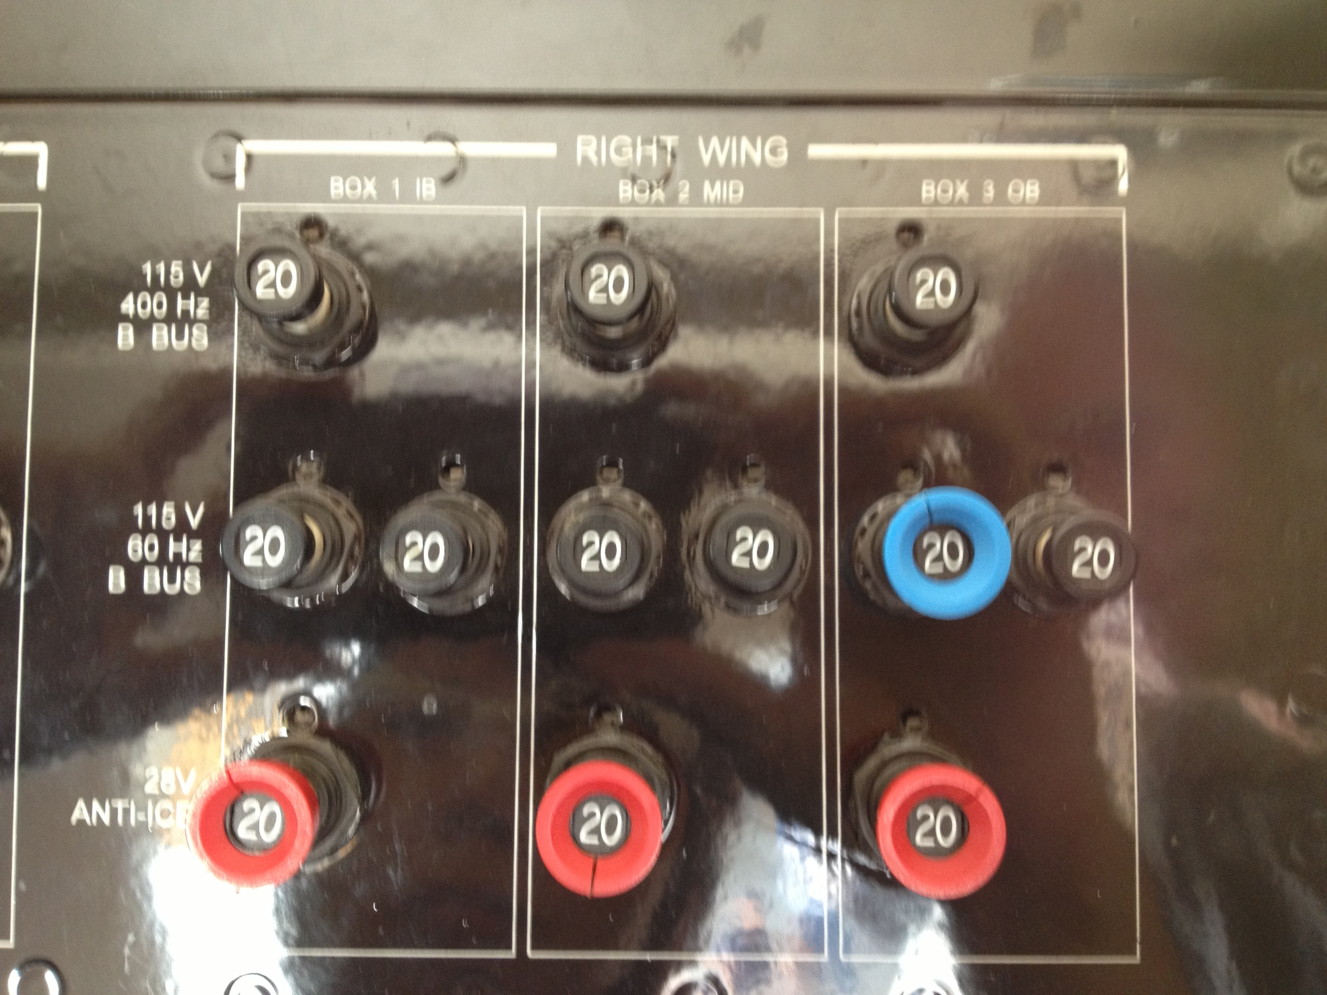

Radar power

*RXR, RDS (2)*

PSM power

*Xmitter (1)*

Motion Ctrl power

*Nosecone (3)*

|  |
| --- |
| **Shutdown Procedure - Radar** |
| ☐ Click on GUI ‘Request High Voltage’ |
| ☐ Click on GUI ‘Filament’ |
| ☐ Click on ‘Stop hcrdrx’ on final approach |
| ☐ Perform steps below ***after*** landing |
| ☐ ‘**stop_all**’ in RDS terminal window |
| ☐ Close HawkEye display |
| ☐ ‘**sudo poweroff**’ on RDS *(sun-dog)* *(Execute after logs completed)* |
| ☐ Close HCR GUI window |
| ☐ Power off IF Box |
| ☐ Power off CMU |
| ☐ Pod power is now safe to remove |

|  |
| --- |
| **Shutdown Procedure - Archiver** |
| ☐ Look at ‘View archive.log’ status |
| ☐ Verify the last time-series file was copied. *(Compare time stamp of last file)* |
| ☐**‘stop_all’** command at prompt |
| ☐ Shutdown Archiver computer |

|  |
| --- |
| **Configure HCR to Scan** |
| ☐ Click ‘Change Scan Mode’ button |
| ☐ Select ‘Pointing’ Tab |
| ☐ Set HCR to point at 0 deg |
| ☐ Click ‘Ok’ to confirm changes |
| ☐ Select ‘Scanning’ Tab |
| ☐ Input scan parameters |
| ☐ Click ‘Ok’ to confirm changes |

|  |
| --- |
| **Configure HCR to Pointing from Scanning** |
| ☐ Click ‘Change Scan Mode’ button |
| ☐ Select ‘Point’ Tab |
| ☐ Input Pointing parameter |
| ☐ Click ‘Ok’ to confirm changes |

|  |
| --- |
| **Noise Source CAL – in flight\*** |
| This assumes HCR was in transmit mode: |
| ☐ Change Ops Mode – Noise Source CAL |
| ☐ Calibration for 5 minutes |
| ☐ Change to Ops Mode |
| *(* The beam pointing angle is irrelevant to NSCAL.**There is no need to change any setting on pointing)* |